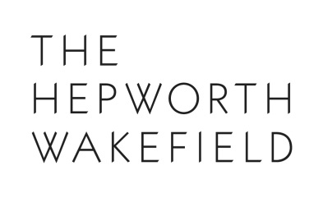

THE MULTIPLE SHOW
Featuring prints and editions from The Hepworth Wakefield

18 – 27 September 2019, Zuleika Gallery, London

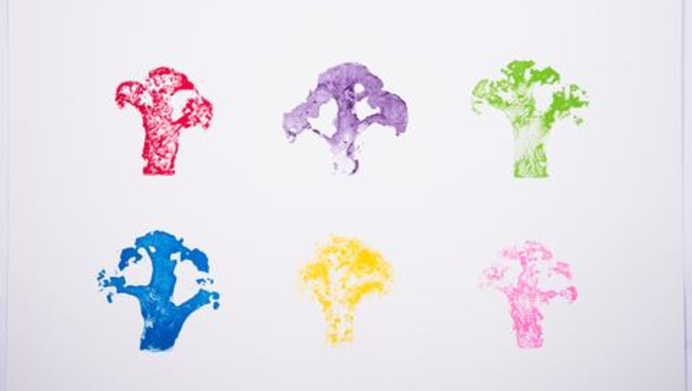

London’s Zuleika Gallery is delighted to announce ‘The Multiple Show’, an exhibition in collaboration with The Hepworth Wakefield. The exhibition runs from the 18th – 27th September and admission is free. On display in the exhibition will be a series of artists’ editions provided by The Hepworth Wakefield alongside editions and multiples by artists Zuleika Gallery works with, including a new edition by Liz West whose ambitious installation ‘Iri-Descent’ is being unveiled at nearby Fortnum & Mason as part of the London Design Festival.

Since opening in 2011, The Hepworth Wakefield has worked with a host of international artists on a programme of hugely successful exhibitions. Through this, they have developed an exciting portfolio of artists' editions produced in collaboration with some of the most significant contemporary artists working today.

Artists editions provided by The Hepworth Wakefield include lithographs by artists Helen Marten, Martin Creed, Jeremey Deller, Rose Wylie and Sir Peter Blake as well as sculptural editions by artists Steven Claydon, Lynda Benglis and Anthea Hamilton.

Kath Knight, Director of Business and Operations said: “We are delighted to have the opportunity to showcase our exceptional range of artists editions that we have commissioned over the last eight years in this exhibition at Zuleika Gallery. We are very lucky that such high calibre artists generously create new work in support of The Hepworth Wakefield as all proceeds directly support our mission to create unforgettable art experiences that inspire, captivate surprise and enhance lives. We hope this new exhibition in London will introduce our editions to new audiences.”

NOTES TO EDITORS

ABOUT ZULEIKA GALLERY

Founded in 2015 by Lizzie Collins, who also curates the Art program for the Saïd Business School, University of Oxford, Zuleika Gallery’s focus is on established and emerging contemporary art. With it’s inception in Oxford, the gallery is named after Max Beerbohm’s comedic heroine, Zuleika Dobson. Zuleika Gallery is now situated above the Stephen Ongpin and Guy Peppiatt gallery and next to White Cube in Masons Yard, in the heart of St James’s, London.

Zuleika Gallery | 3rd Floor | 6 Mason’s Yard | St James’s | London | SW1P 6BU
Transport: Green Park and Piccadilly Circus

Opening Hours: Monday – Friday 11-6pm
Saturdays: 12-3pm
Sundays: By Appointment Only

info@zuleikagallery.com
www.zuleikagallery.com

ABOUT THE HEPWORTH WAKEFIELD

Designed by the acclaimed David Chipperfield Architects, The Hepworth Wakefield is set within Wakefield’s historic waterfront, overlooking the River Calder. The gallery opened in May 2011 and was awarded Art Fund Museum of the Year 2017. Named after Barbara Hepworth, one of the most important artists of the 20th century who was born and brought up in Wakefield, the gallery presents major exhibitions of the best international modern and contemporary art. It is also home to Wakefield’s art collection – an impressive compendium of modern British and contemporary art – and has dedicated galleries exploring Hepworth’s art and working process. In August 2019, the first phase of The Hepworth Wakefield Garden opened alongside the gallery. Designed by Tom Stuart-Smith, the garden features sculptures and is one of the largest free public gardens in the UK.
www.hepworthwakefield.org

